4 Screw Adapter

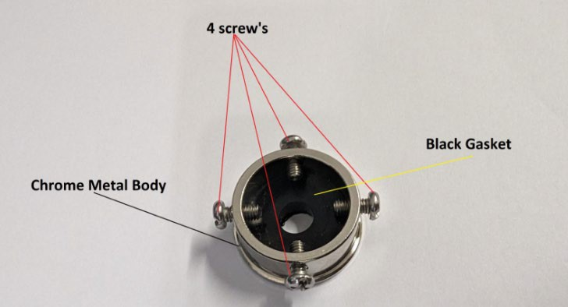The 4-screw adapter comprises of a circular metal body, 4 screws and a thick black gasket.

Make sure the gasket that came with it needs to be there.

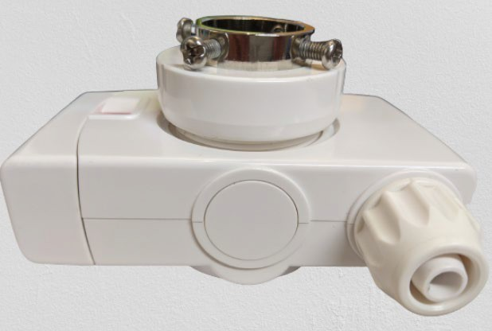

**Gap of 2 to 3 twists.**

Don’t tighten the diverter ring all the way down to the bottom. Leave a gap of 2 to 3 turns.

It works on the faucets that have no threads and are less than 1 inch in diameter.

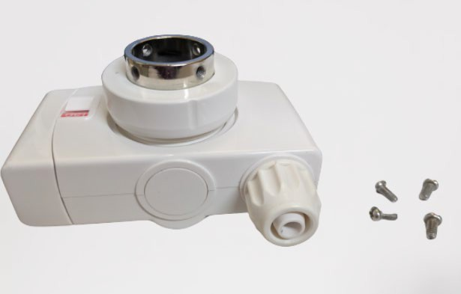Simply take all the 4 screws off from the adapter. Lock the adapter on the plastic diverter.

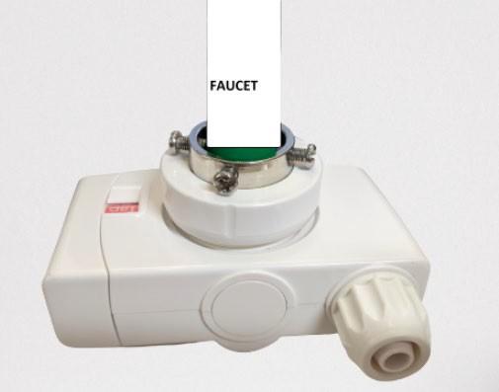Place the diverter to the faucet and start tightening the screws.

Better to have two people working on it as one person holding the diverter and the faucet and the other one for tightening the screws.

Try to have the faucet in the middle and 4 screws around it at the same distance.

Now the gap that was left from before can be closed by twisting the diverter and making it tight. Install the machine water supply hose and start using the machine.

*Enagic Canada does **not** guarantee nor give any assurance that this product is going to work on your faucet.

By purchasing this product, you hereby agree to these terms and conditions and cannot hold Enagic Canada responsible.