Enagic Canada Corp. Suite #101-7460 Edmonds Street,
Burnaby, BC, V3N 1B2, Canada
Phone 604-214-0065 Fax 604-214-0067
Website https://www.enagic.ca/
Ultra-E Prefilter
Instruction Manual
Dear Enagic Distributors,
This manual is an important instruction manual so please read it before installation.
The Ultra-E Prefilter comes with the casing, an Ultra-E Prefilter cartridge inside and a 1-meter water supply hose.
The Ultra-E Prefilter needs to be placed between the water source and the machine.
At the bottom of the Ultra-E Prefilter, you will see “IN” & “OUT”.
The machine water supply needs to be connected to the “OUT” end of the pre filter whereas the hose came with the unit needs to be connected to the “IN” end of the pre filter.
The other end of the water supply will be connected to the diverter.
What you need….
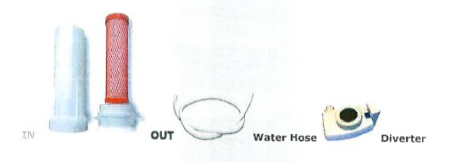
Caution:
Ultra-E Prefilter is on the counter unit.
The water needs to be shut off while the unit is not in use.
Metal clamps are not included.
If you have any questions, please contact your sponsor or our service department.
Update 02/10/2017

